**Brave Llama Games Brief**

**for**

**Clumsy Bat**

# The concept

Clumsy bat is a deceivingly cute and playful 2D side-scrolling avoidance game. In concept, Clumsy Bat is a spin-off of Flappy Bird, with added abilities, obstacles, and RPG elements. It is designed for touch-screen mobile devices to accept gestures to control the character to get to the end of each level unscathed.

Players will need to brave the perilous caves full of spikes, vision impairing mushrooms and spiders, and collect the ever-useful essence from moths scattered throughout the cave. Then they will find and solve puzzles to unlock abilities such as Hypersonic and Rush. Only with these abilities will Clumsy make it through to the end and save the Gnome Village from certain corruption.

# Team and Contact details

**Main Contact (liaison)**

Dan Szabo [d.szabo87@gmail.com](mailto:d.szabo87@gmail.com)

**Team Members & Responsibilities**

Scott Robinson Artist

Dan Szabo Programmer, Designer, Technical Artist

# Artwork & Visual References

Artwork for Clumsy Bat, including the game’s icon, title graphic, menus, in-game screenshots and other objects.

Note that the cave background will change colour as the player progresses through the story mode.

**Game Icon**

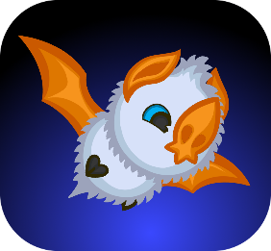

**Main Menu**

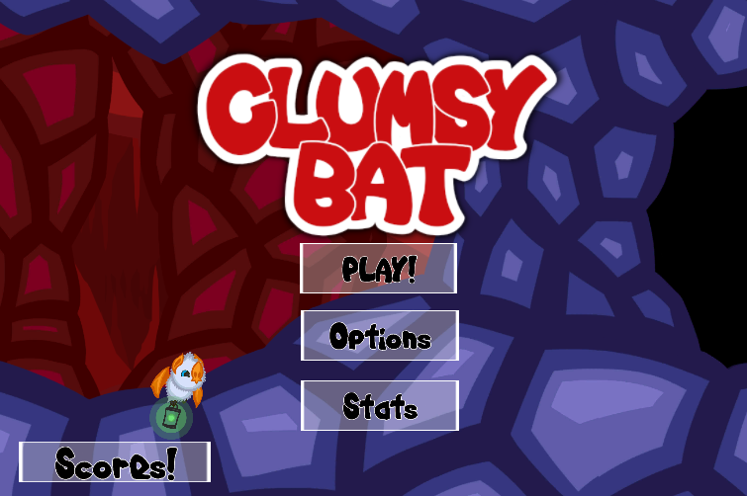

**Level Select**

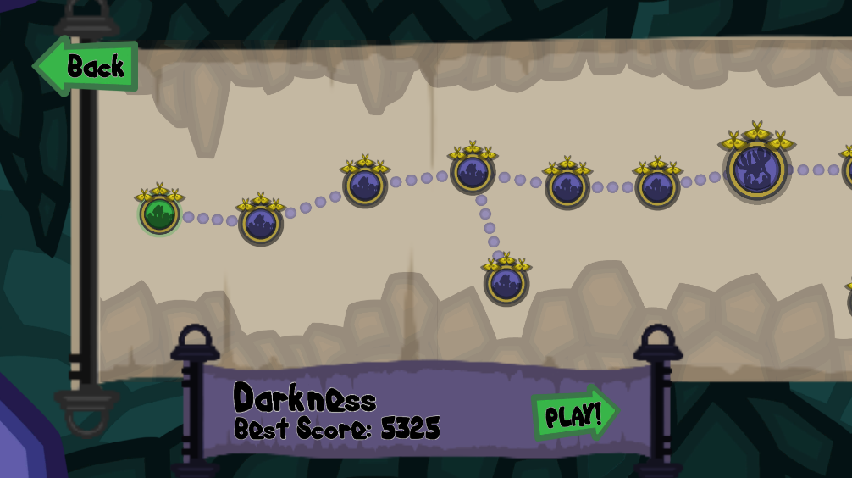

**In-Game 1**

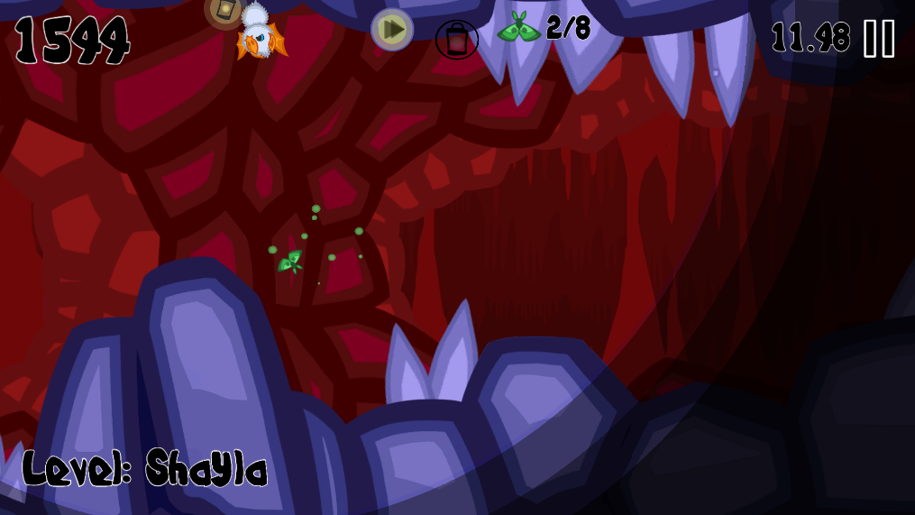

**In-Game 2**

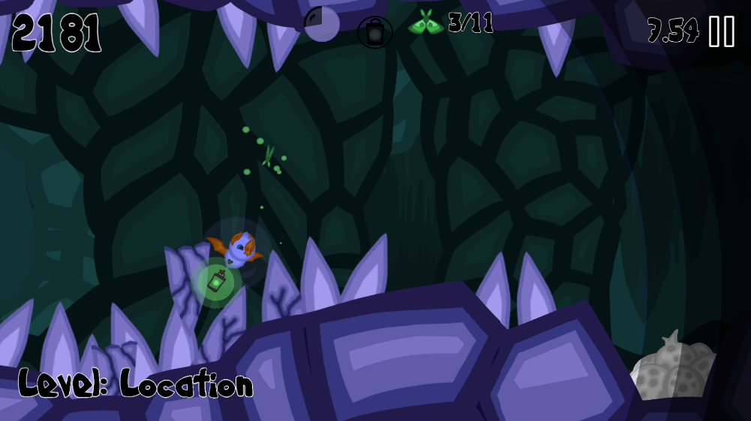

**In-Game Dialogue**

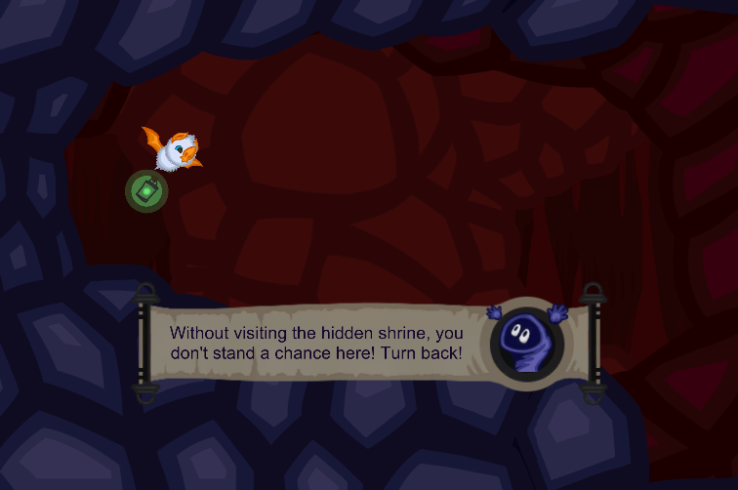

**Puzzle Level Win-Sequence**

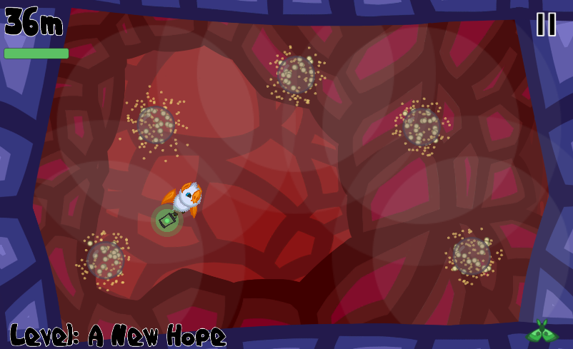

**Boss Level**

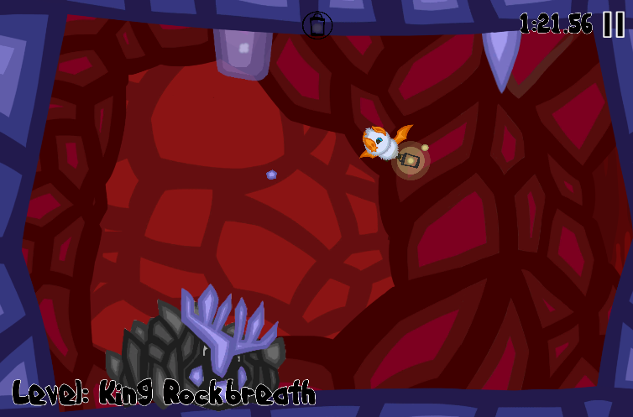

**Characters, NPCs and other game objects**



|  |  |  |  |
| --- | --- | --- | --- |
| **Name** | **Type** | **Description** | **Image** |
| **Clumsy** | Character | The main character, controlled by the player. |  |
| **Nomee** | NPC | Elder of the Nome village, assist the player with dialogue and tips throughout the adventure. | C:\Users\dszab\AppData\Local\Microsoft\Windows\INetCache\Content.Word\No-Me.png |
| **Moth** | Collectible | When collected, brings the lantern back to maximum light and gives the player a shield charge. Yellow and blue moths also activate special abilities. |  |
| **Spike** | Obstacle | Common obstacle scattered throughout the caves. Most are static, and some fall. They can be crumbled by Clumsy’s Hypersonic ability.  Clumsy takes damage (and cracks the spike) when touched by one. | Normal Crumbled |
| **Mushroom (and spores)** | Obstacle | Releases spores when near clumsy. If Clumsy gets caught in the spore cloud, vision is greatly reduced. |  |
| **Spiders** | Obstacle | Descends or swings from the cave’s ceiling when clumsy is nearby. |  |
| **King Rockbreath** | Boss | The first (and currently the only) boss, who Clumsy will face multiple times throughout the adventure. Each time, King Rockbreath’s abilities will get stronger and more difficult. |  |

# The Music

## Level Loop

**Mood:**

The music should feel **echoic**, but not dreary. The game is cartoony and playful and we want to evoke the feeling of **fun and playfulness**, with **hints of dissonance** to tease inevitable difficulty of the later levels of the game.

During the boss levels, the music should be more intense while maintaining the feel of playfulness.

Optionally, during puzzle levels, the music can be more relaxed.

**Audio mood samples:**

A playful and cheery tune, which could be made more echoic and with less 8-bit:

<https://www.youtube.com/watch?v=0qKF2y3I9Pc>

A slower bit of cave music from Pokemon:

<https://youtu.be/bRtme5eLePo?t=17m25s>

8:32 to 8:44 of the Forest Temple music from The Legend of Zelda for ambience: <https://youtu.be/huN376F3QTg?t=8m32s>

An over the top level of intensity, which could be scaled back for boss fights (and made less chiptune):

<https://youtu.be/bRtme5eLePo?t=1m30s>

## Musical Stings and Sound Effects

Musical stings and sound effects should be in the same context as the music described above – echoic and playful. The table below details the music and sounds needed for the game:

|  |  |  |
| --- | --- | --- |
| **Category** | **Event Name** | **Description** |
| **Soundtrack** | Menu | Something simple, could be the level-loop music or just ambiance |
| **Soundtrack** | Level Select | As per the menu |
| **Soundtrack** | Level Loop | As described above |
| **Ambiance** | Ambient Cave Sounds | Dripping, creaking sounds, with light echoic, chamber-like wind. |
| **UI** | Button clicked | When the player taps a menu button |
| **UI** | Screen transition | Optional – when the game transitions between menu and level select, or into a level from the menu (and back) |
| **UI** | Dropdown menu | Optional – when the in-game menu/gameover/win screen is displayed |
| **Sting** | Gameover | Played when the player fails to complete a level |
| **Sting** | Level Complete | Played when the player successfully completes a level |
| **Sting** | Achievement | Played when the player earns a new achievement after completing a level |
| **Category** | **Event Name** | **Description** |
| **Clumsy** | Flap | When the player taps the screen, Clumsy flaps his wings once or twice |
| **Clumsy** | Perch | Clumsy can perch on the cave’s ceiling or floor, which causes tiny bits of rubble to fall. |
| **Clumsy** | Death | We’re thinking something along the lines of a pathetic “ow” sound, which is followed by the gameover/restart level screen |
| **Clumsy** | Collision | When Clumsy hits his head on the ceiling of the cave. This will happen very often and only stops Clumsy from moving forward briefly (no damage taken), so it can be incredibly short and soft. |
| **Nomee** | Dialogue indicator | Occurs when a dialogue message is available for the player to activate by tapping an icon at the top of the screen. |
| **Nomee** | Scroll opening and closing | Played when the dialogue window (a scroll) opens or closes |
| **Nomee** | Dialogue | Optional – when Nomee begins to talk to Clumsy through the lantern, on a scroll (because this makes sense) |
| **Moth** | Moth fluttering | Something very soft, either a fluttering sound or a shimmering sound. |
| **Moth** | Moth touched | Occurs when a moth is touched and starts to morph into essence |
| **Moth** | Moth collected | Occurs when the moth essence is collected by the lantern. Current sound is similar to the coin-sound from Mario, or the ring sound from Sonic. |
| **Spike** | Player collision | When the player hits a spike, it will crack |
| **Spike** | Shatter | When hit by hypersonic, a spike will shatter |
| **Spike** | Falling Spike | Some spikes can fall from the ceiling. Thinking this should be a crumbling sound with a snap at the end as the spike detaches from the ceiling |
| **Mushroom** | Spore release | Played when the mushroom releases a spore. The spore will be emitted from the mushroom as a puffball, then explode into a spore cloud and fade away |
| **Spider** | Descent | Played when the spider descends from the ceiling on a web string |
| **Spider** | Swing | Played when the spider swings from the ceiling on a web string (can be the same as descent, played at the start of the swing, e.g. a skittering sound) |
| **Spider** | Collision | Played when the player collides with a spider |
| **Ability** | Hypersonic activated | Occurs when the player collects a Gold moth. This causes a powerful sonic blast that destroys spikes, stuns spiders and damages bosses. |
| **Ability** | Shield activated | Occurs when the player takes damage and has a shield charge. The effect looks like a bubble around Clumsy. |
| **Ability** | Dash | A whooshing sound when the player activates dash (increases speed and does a barrel roll for 0.3 seconds). |

|  |  |  |
| --- | --- | --- |
| **Category** | **Event Name** | **Description** |
| **Rockbreath** | Movement | King Rockbreath is a rock boss who moves slowly along the level when not using an ability. I imagine this as a shuffling sound with a light stomp each step. |
| **Rockbreath** | Dash | Rockbreath dashes into a wall. This requires a startup sound as well as a collision sound when he slams into the wall (causing the screen to shake) |
| **Rockbreath** | Damaged | When Clumsy activates hypersonic, Rockbreath will take damage and lose a tooth or his antlers |
| **Rockbreath** | Death | Rockbreath will explode into a pile of rocks after taking 4 hits of hyperonic. The rocks bounce on the floor briefly |

# Version Control

|  |  |  |  |
| --- | --- | --- | --- |
| **Version** | **Date** | **Author** | **Description** |
| 1 | 11-Sep-2017 | Dan Szabo | Initial Version |
|  |  |  |  |